1. What are your values, then?
- A value as well as a strength that makes me confident the most is flexibility. I think this is the factor that helps me to solve all problems as well as streamline my work order. Therefore, being flexible in urgent situations also helps me to suppress negative emotions and calmly solve problems.
- Another factor I want to mention in my values ​​is decisiveness and meticulous. I won't be swayed by my decision after careful consideration. Although this is a bit extreme, I believe in seeing and evaluating a problem on my own.
- I see myself as a person of connection value. I know how to connect people around in presentations as well as in real life relationships. This is also a value that I am very confident in having and I will try to develope in the future.

2. Which are most important to you, and which are least important?
- I think what makes me special from the crowd is that I am quite meticulous and pay attention to small details. I always want everything I do to be perfect. I want all directions for my plan to be carefully planned before implementation, even the worst possible situations must be prepared. I will not work where the probability of success is low. For me, the time I spend on a project is not as important as the results I get after my efforts.
- When it comes to self-worth, we can't say which value is the least important. However, of the 3 values ​​that I mentioned above, the connection value is the least important.

3. How do your values fit into your educational goals?
- Currently, I am studying Software Engineering, so I realize that my meticulousness is very necessary. The computer may not work even with an extra dot. Carefulness will help me avoid unnecessary small mistakes.

4. How do your educational goals relate to your future career?
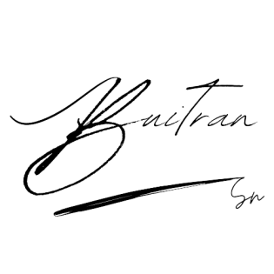
- When avoiding small mistakes in the work that we are pursuing. I hope, 5-10 years after the university, I can settle down in a position that is suitable for my major, economic stability as well as other minor issues.

